Week 2 – TCP/IP review

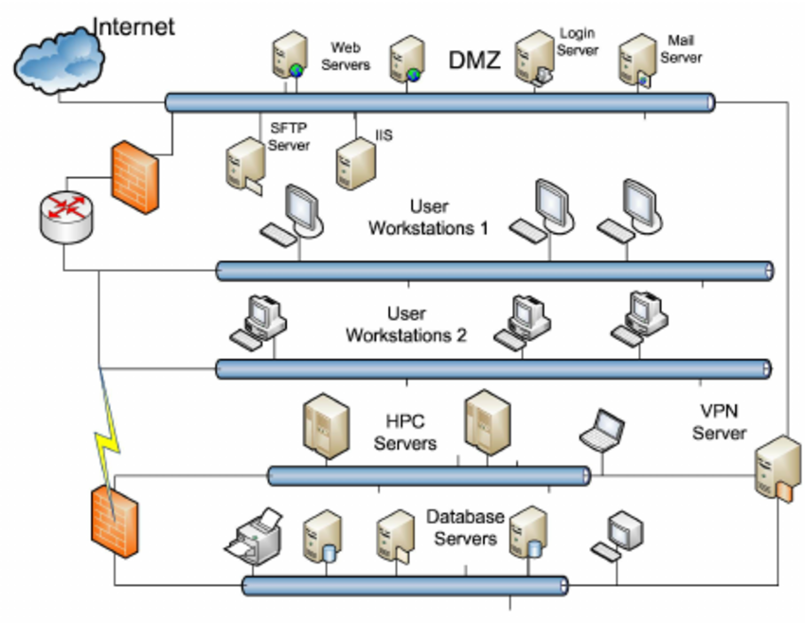
Background
The diagram above shows a small enterprise network. The network includes five subnets:
1 - DMZ (Demilitarized Zone) that hosts 35 publicly accessible servers
2 - two internal subnets used for 500 user workstations
3- a high-performance computing servers subnet consisting of 17 servers
4. – a database servers subnet consisting of 50 servers and other related devices
The general firewall configuration allows the Internet to visit the servers in DMZ through the respective ports. Some of the hosts in the two workstation subnets can reach the database servers and the HPC servers.

Provide the following information:
1. The IP address of 148.137.10.10 is associated with what part of the diagram?
The class B IP address is associated with medium sized networks thus it will be associated in the Demilitarized Zone.
2. What class is this address and what is the default subnet mask for this class?
This is a class B IP address. The default subnet mask is 255.255.0.0. The IP range is 128-191
3. Create a network IP range for each of the 5 subnets and justify your answer.
a) DMZ 35 Hosts (Public IPs)148.137.10.0/26 (255.255.255.192)
The IP Range is from 148.137.10.1 to 148.137.10.62.
/27 has 32 Hosts which is not fit for the networks, we are left with /26 which has 64 hosts. /26 will be the best option as the number of unused IP addresses will be lower.
b) Internal with 2 subnets each 500 hosts
User works station 1
172.16.0.0/23 (255.255.254.0)
The IP Range is from 172.16.0.1 to 172.16.1.254
This has a total of 510 usable host addresses
User work station 2
172.16.2.0/23 (255.255.254.0)
The IP Range is from 172.16.2.1/23 to 172.3.254/23
c) High performance Servers (17 hosts) - 200.10.10.0/27 (255.255.255.224)
The IP range is from 200.10.10.1 to 200.10.10.30
d) Database Server 50 Servers IP Address
150.101.45.0/26 (255.255.255.192)
The IP Range is from 150.101.45.1 to 150.101.45.62
4. The total number of hosts is around five hundred. If you were creating a custom subnet mask for the two host networks, what subnet mask would you use and why?
The subnet mask that I would prefer would prefer is /23. This subnet mask will be able to support 512 hosts in the network.

5. What is the purpose of the DMZ?
The main purpose of establishing a DMZ is to bring about an additional layer of network security. The local area network will have more control over external access. The DMZ will be in a position to expose what it has to external nodes while the remaining network is protected by the firewall.
6. Why is there a firewall and router between the DMZ and the two internal subnets used for user workstations?
a) It functions as an additional network security to the external network nodes.
b) All the inbound network packets are able to be monitored via the installed firewall before reaching the servers hosted in the DMZ.
7. Can someone accessing the webservers in the DMZ access the database server subnet? Explain your answer.
NO. The DMZ is a special network zone that handles external traffic and prevents external nodes from accessing the internal local area network. The database server subnet has a firewall installation thus its access is monitored. If the access was allowed, the attackers would have an easy job sabotaging the whole network.
8. Can traffic from the HPC servers access the database servers? Explain your answer.
Not all traffic can access the database servers due to presence of the firewall mechanism. All the traffic will be monitored thus requiring necessary credentials to log onto the database servers.
9. Why is the VPN server not in the DMZ?
The virtual private network should be positioned inside the internal network or the local area network of the organization.
10. Which of the servers or client machines would be a target of attackers? Explain your answer.
The likely target would be the database server. Large amount of information relating to the organization and client confidential details are stored here. When certain important user credentials are exposed to the hackers, it will be easier to access the other sections of the network including the High Performance Computing servers and user workstations. The system could be greatly affected when this information is stolen or erased as it depends on the integrity of the stored data.

References
Dart, E., Rotman, L., Tierney, B., Hester, M., & Zurawski, J. (2014). The science dmz: A network design pattern for data-intensive science. Scientific Programming, 22(2), 173-185.
Jorgensen, J. W. (2018). U.S. Patent Application No. 15/653,161.
Vardy, A. (2016). Subnetting For Beginners: How To Easily Master IP Subnetting And Binary Math To Pass Your CCNA-CCNA, Networking, IT Security, ITSM. CreateSpace Independent Publishing Platform.

